Christian Legal Society

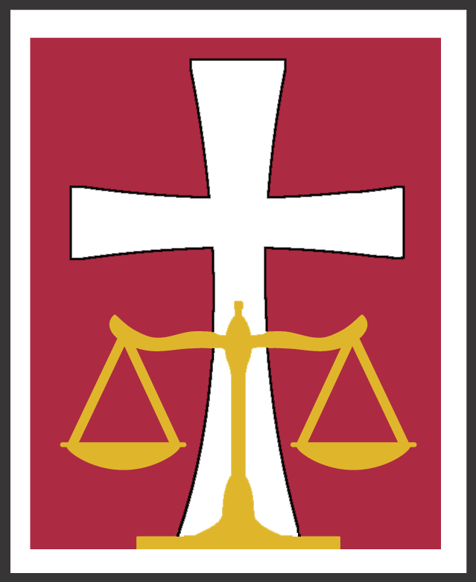

A Call To Discipleship

The Well Discipled CLS Lawyer
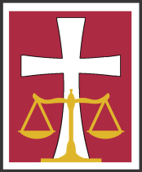
CLS Attorney Ministries Committee
Following are some broad objectives we suggest attorneys consider for their spiritual development and maturity. Certain objectives will apply to some but not others.
I. Spiritually Mature
- Active in a local fellowship of believers as a worshipper, donor, and disciple and/or teacher.
- Possesses character and other virtuous traits required of church leaders.
- Exhibits the fruit and gifts of the Holy Spirit and seeking to grow in them.
- Has an active prayer life, including time alone with God and prayers for self, family, practice, clients, colleagues, opponents, and judges.
- Knows how to give a personal testimony including how God has used him or her in legal practice to carry out God’s purposes on earth.
- Knows how to lead a seeker to a saving Knowledge of God through Jesus.
II. Biblically Literate
  - Understands and can articulate reasons for signing the CLS Statement of Faith.
Trusting in Jesus Christ as my Savior, I believe in:
    - One God, eternally existent in three persons, Father, Son and Holy Spirit.
    - God the Father Almighty, Maker of heaven and earth.
    - The Deity of our Lord, Jesus Christ, God’s only Son, conceived of the Holy Spirit, born of the virgin Mary; His vicarious death for our sins through which we receive eternal life; His bodily resurrection and personal return.
    - The presence and power of the Holy Spirit in the work of regeneration.
    - The Bible as the inspired Word of God.
  - Can articulate arguments for the reliability of scripture.
  - Actively growing in the knowledge of the Word through personal and corporate Bible study participation or other means.
  - Relies on scripture for guidance, inspiration, direction, and intimacy with God.
  - A student of Christian apologetics and knows Messianic prophecies.

III. Politically Literate
- Given thought and prayer concerning the overlapping nature of law, faith and politics including (by way of example and not limitation) the protection of the unborn, racial justice, sexual morality and orientation issues, marriage and family protection, care for the environment, education and poverty issues.
- Able to knowledgeably address world political events in light of God’s disclosed plan and purpose for humanity.
IV. Socially Involved
- Significant pro bono, church, or other social service work.
- Publically identified as a believer at work and among friends.
- Attends CLS conferences and local chapter meetings regularly as the Lord allows.
V. Legally Equipped
- Can intelligently discuss the role of Biblical law (Torah), natural law, Constitutional law, and positive law in relation to a just society and helping people realize their need for the Savior.
- Gives thoughtful consideration as to how his or her faith bears on the policies implicated by important legal decisions that broadly affect our nation.
- Has meditation/peacemaking skills.
- Has a well-developed understanding of the Biblical basis for serving clients and other constituents well in the legal field in which the CLS member works.
VI. Has Vision
- The CLS lawyer should know or be actively seeking to know how God wants to use him or her personally to build His Kingdom through the member’s practice of law and how God wants to use the law and legal profession to affect America and the world for Messiah.
- The CLS lawyer should understand and welcome the challenge to become mature and equipped in Jesus including the personal responsibility to disciple others, particularly lawyers.

We recognize this vision for a well discipled lawyer will grow and become clearer as we implement it:
The path of the righteous is like the first gleam of dawn,
shining ever brighter till the full light of day.
Proverbs 4:18

The CLS Board of Directors approved “The Well Discipled CLS Lawyer” statement in June 2009. The CLS Attorney Ministries Committee thereafter added the Scripture annotations to the statement.
Hebrews 10:25; 2 Corinthians 9:78; Romans 12:6-8; 1 Peter 2:5; Roman 12:4-8.
1 Timothy 3:1-13; Titus 1:5-8; Hebrew 6-1-2; Ephesians 4:11-16.
Galatians 5:22-25; 1 Corinthians 12:1, 28-30; 2 Peter 1:3-11; John 14:14-17, 26.
1 Thessalonians 5:17; Matthew 6:6; James 5:16; I Timothy 2:1; Ephesians 6:18.
I Peter 3:15; Ephesians 6:19-20.
II Timothy 2:24-26; II Peter 3:18; Romans 3:21-26.
II Timothy 1:12-14; Romans 1:16.
II Timothy 2:15; Luke 1:1-4; John 5:31-39.
I Peter 2:2.
Psalm 119.
Acts 3:11-4:13; 7:1-53; 17:16-31; 23:1-26:29.
Matthew 22:15-22; Psalm 139:13-15; Galatians 3:28; Colossians 3:11; Romans 1:18-27; Ephesians 5:22-31; Ephesians 6:1-4; Psalm 37:3; Luke 2:46; 52, Proverbs 22:22.
Ephesians 1:9-12.
Galatians 5:13.
Matthew 10:32.
Hebrews 10:25.
Psalm 1:2.
I Kings 3:6-10.
Matthew 5:9.
Titus 3:13-14.
Hebrews 13:20-21; I Thessalonians 5:23-24; I Corinthians 10:31.
Hebrews 6:1, Matthew 28:19-20; 1 Corinthians 3:6-11.

